**Python Coding Assessment**

**Date :20-12-23**

**Name : Hemalatha Karumuri**

**1.Explain Python Module with examples  
a.Import module in Python**

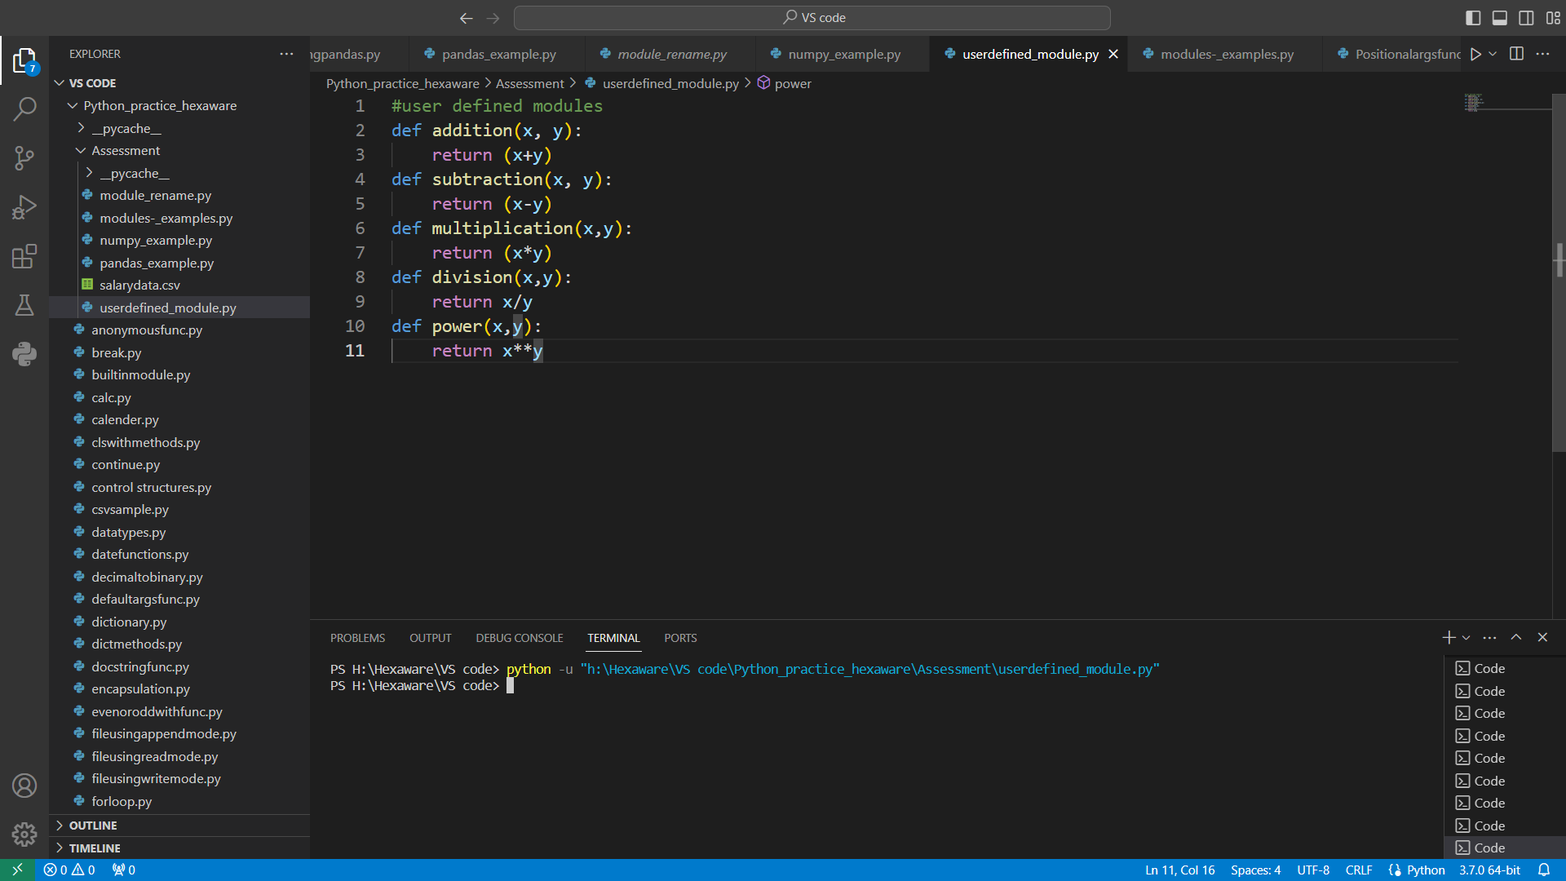

Explanation: creating a user defined module named userdefined_module having the methods like addition, subtraction, multiplication, division and power

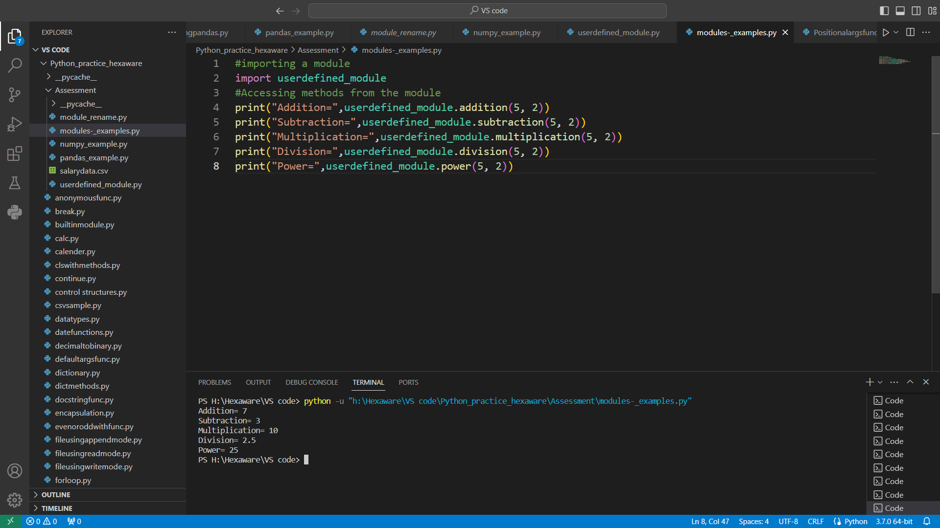

Explanation:we are importing the userdefined_module from another program and accessing all the methods available in the module.

**b. Renaming the Python module**

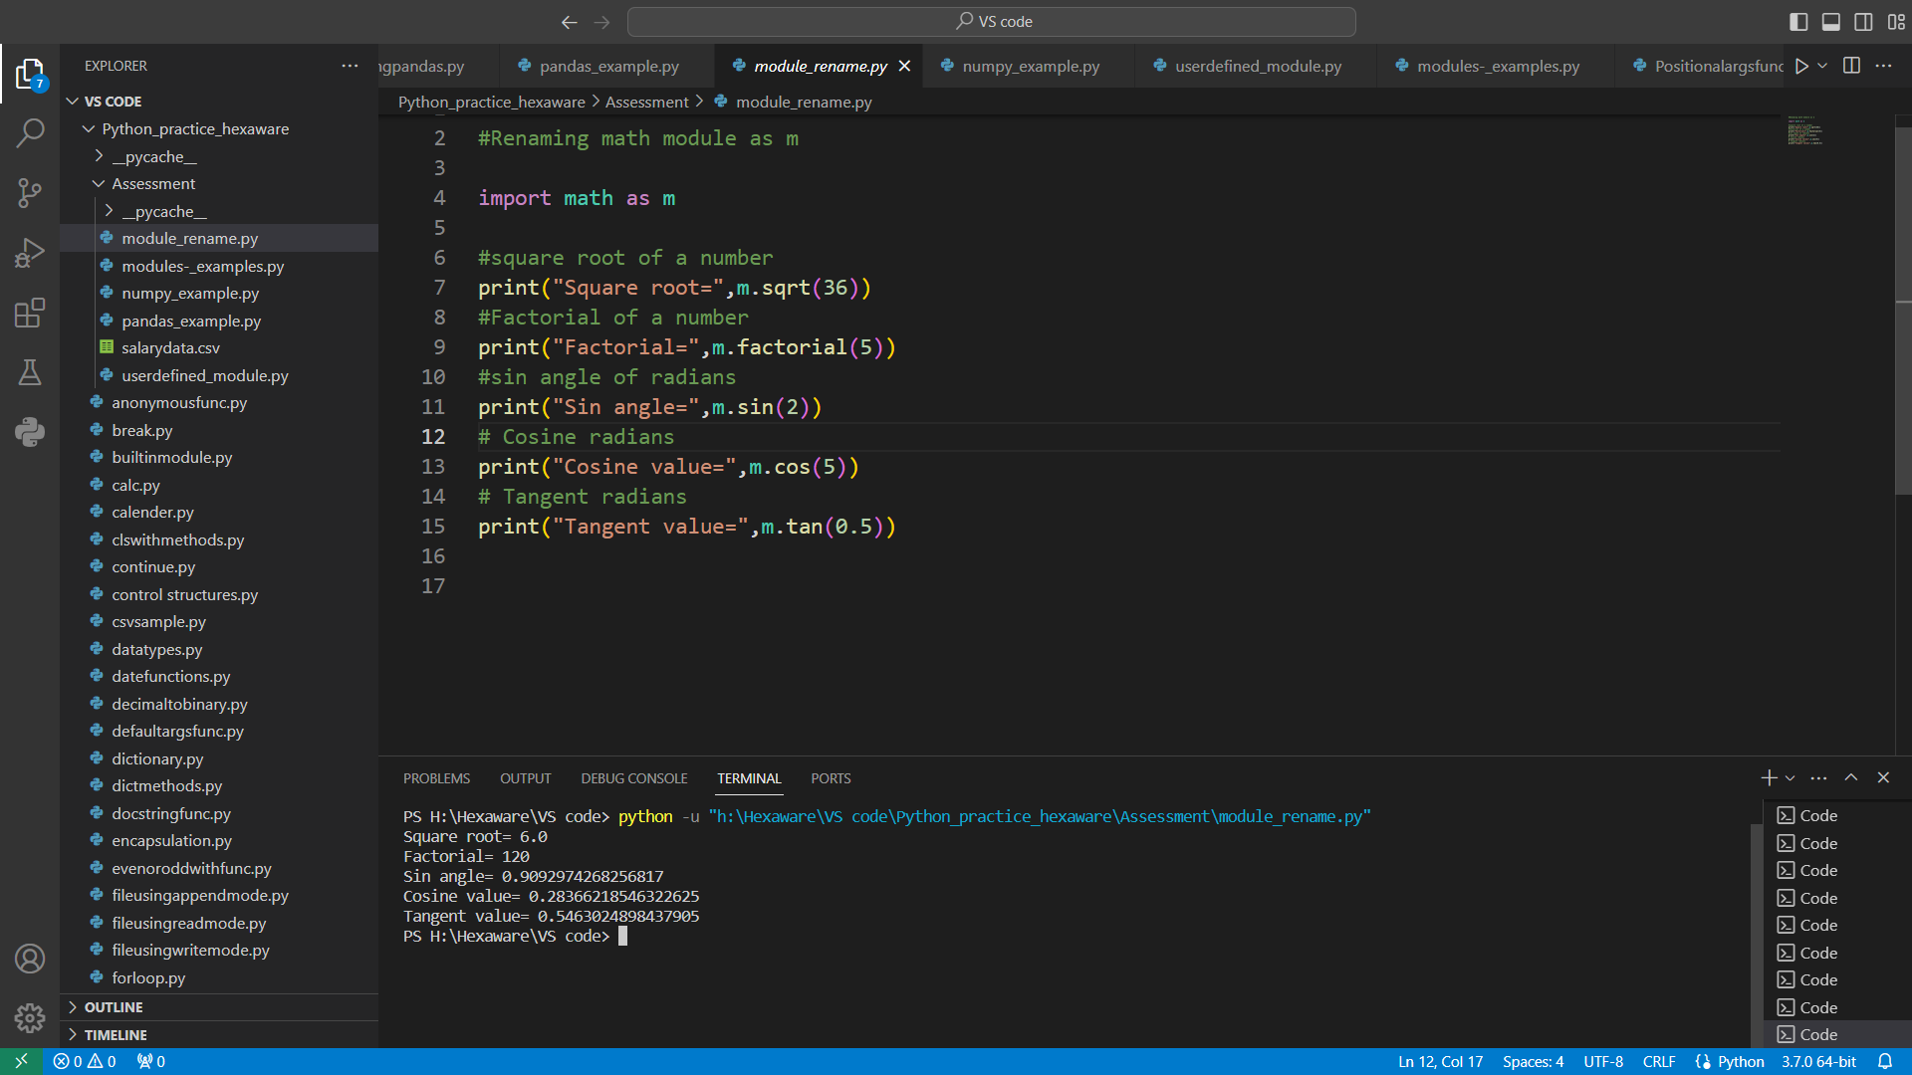

Explanation: We are importing math module and renaming it as m. And we are accessing the methods like sqrt(),factorial(),sin(),cos(),tan()

**2.Explain Pandas and numpy using Examples in PYTHON**

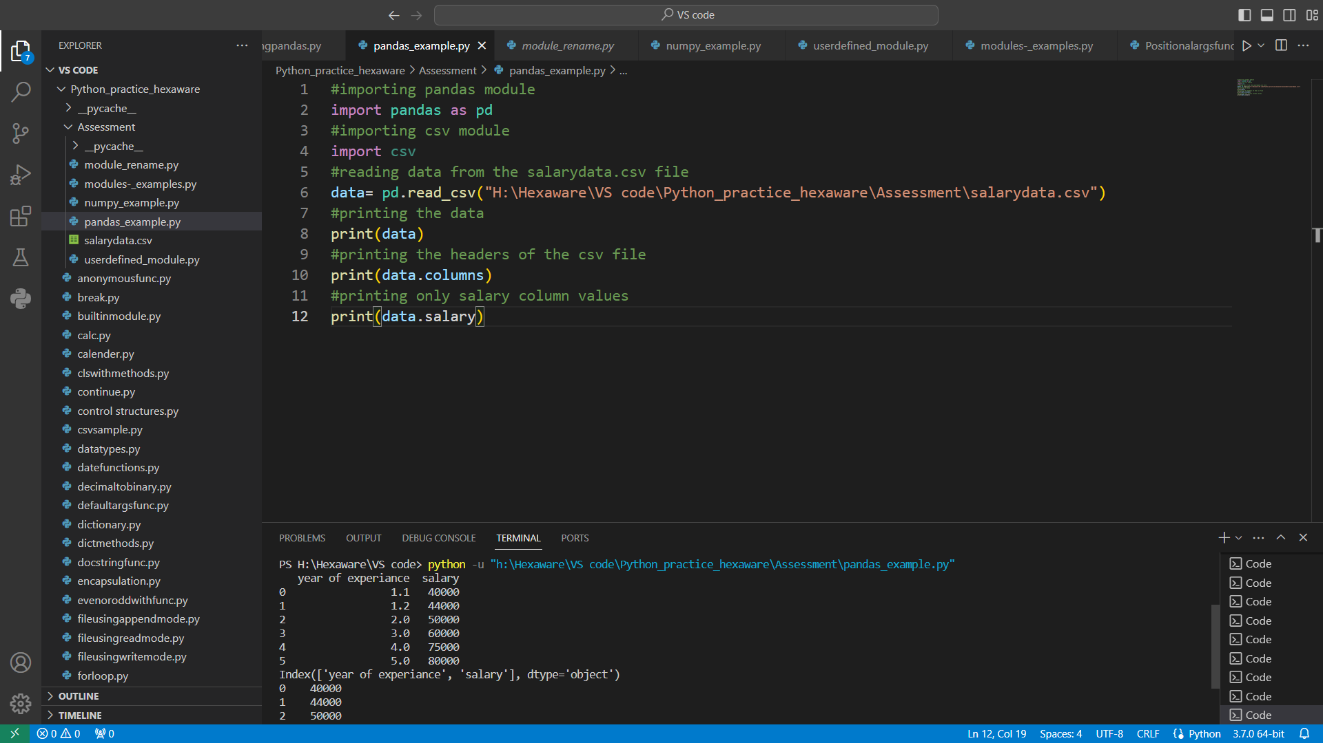

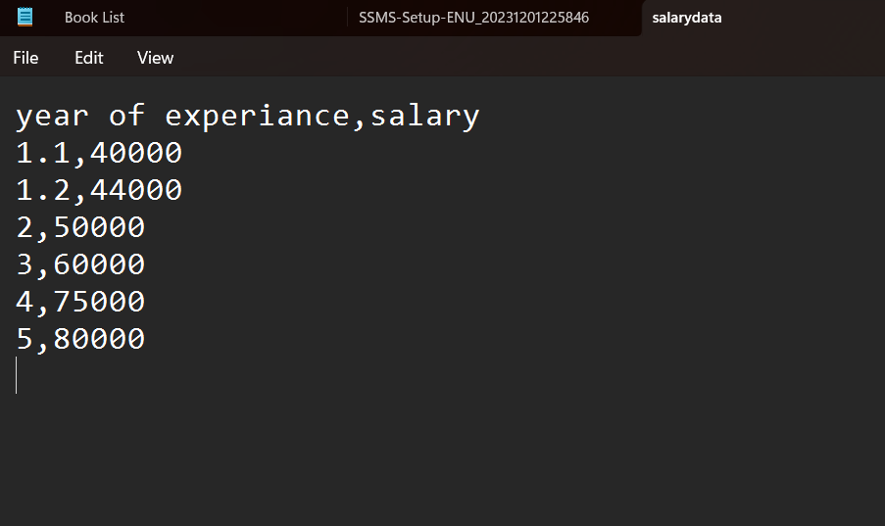

Explanation: we are importing the pandas module and renamed it as pd and also importing csv module.We have taken the file name “salarydata.csv” and we tried to print the data and columns present in the file.

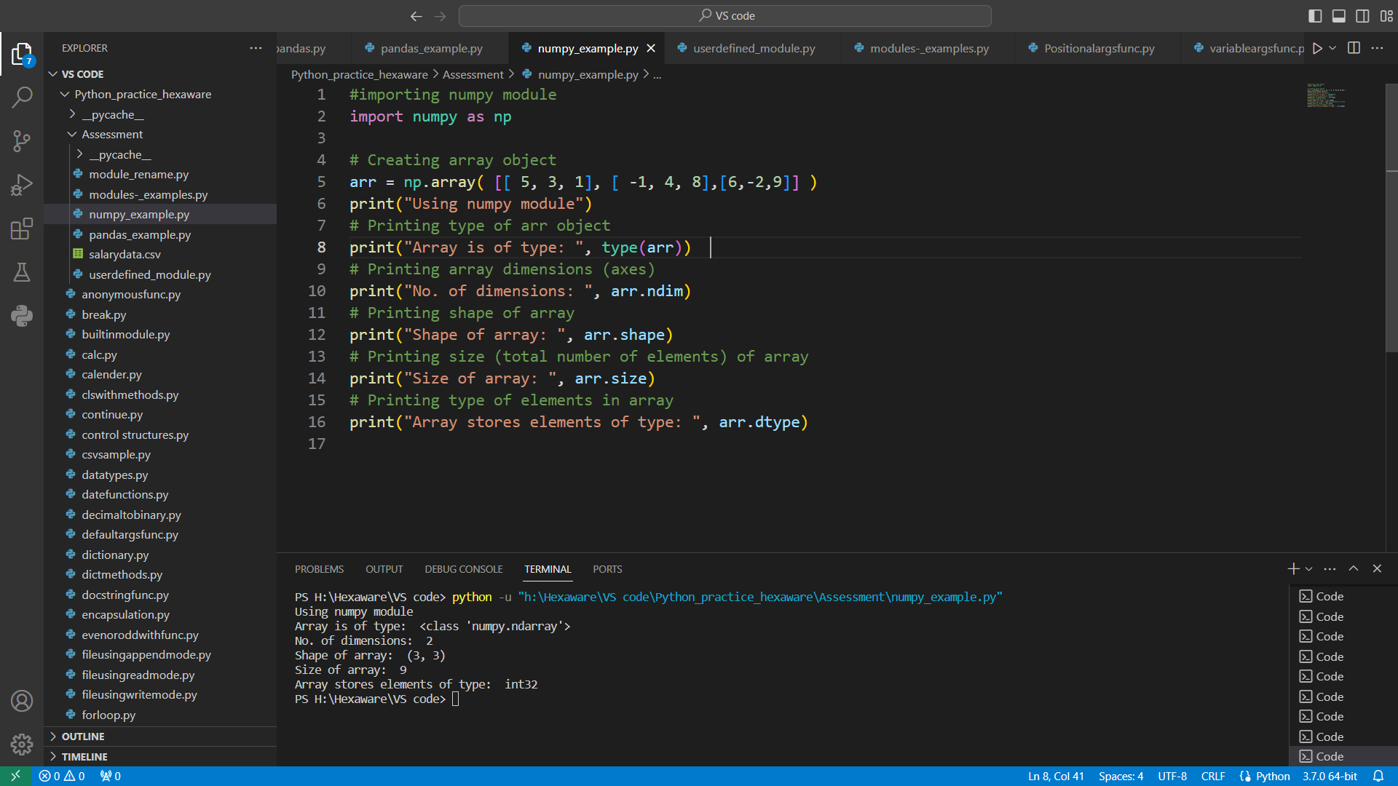

Explanation: We imported numpy module and renamed it as np. We have taken an array named “arr” and printed the type of array using type() method ,no of dimensions, shape, size of an array and data type of an array